Rolling correlation: GBPUSD and AUDUSD
Method 05 / daily log returns / windows 20, 60, 100 / Secondary tier

Study setup
Logical pair: GBPUSD , AUDUSD
Broker symbols: GBPUSD_i , AUDUSD_i
Tier: Secondary tier (secondary)
Snapshot: 2026-11-03_majors_alpari_D1
Timeframe: D1
Matched return window: 1999-01-05 to 2026-11-02 (UTC bar dates)
Matched return count (rows before rolling): 7228
Dropped unfinished last bar dated 2026-11-03 UTC after a tick-volume check against the prior complete day.
Rolling windows W: 20, 60, 100 trading days
Live-shaped n for each score: n = W (not the full history length)
Complete matched rows (CSV): GBPUSD-AUDUSD_Rolling_D1.csv
Complete matched rows (HTML): GBPUSD-AUDUSD_Rolling_D1_data.html

Method carried forward
Rolling Pearson r is computed on matched daily log returns of close, ln(close_t / close_t-1), in the broker quote direction. Quotes are not inverted. For each day t with a full window, r_W uses the last W matched return pairs ending at t. That live-shaped sample size is W (20, 60, or 100), not the full multi-year history. The first W-1 days have no score. r is symmetric under swap of the two symbols. A high |r| in one window does not prove cause, lead-lag, or a trading signal. Short windows are noisier; long windows are slower to reflect a break.
How to read a live day: after both daily candles close, the newest r_20 uses the last 20 matched log returns, r_60 the last 60, and r_100 the last 100. Compare those three to each other and to the full-sample baseline below. A break is when the short window moves far from the baseline or flips sign while the baseline was meaningful.

Full-sample Pearson baseline (method 01 v001)
Copied full-sample Pearson r for GBPUSD-AUDUSD: 0.539048. This is a historical average link, not the live state.

Rolling results
W | latest_r | mean | median | min | max | std | pct_|r|>=0.4 | pct_|r|>=0.7 | n_roll
20 | 0.053272 | 0.511504 | 0.567664 | -0.47111 | 0.934441 | 0.25718 | 71.58 | 27.11 | 7209
60 | 0.443461 | 0.51721 | 0.56034 | -0.08083 | 0.869203 | 0.203305 | 71.7 | 20.31 | 7169
100 | 0.528758 | 0.520407 | 0.554486 | -0.001623 | 0.843599 | 0.187357 | 71.57 | 19.47 | 7129
n_roll is the number of days that had a complete window. pct_|r|>=0.4 and pct_|r|>=0.7 are the share of those days where the absolute rolling correlation cleared the threshold.

Conclusion
For GBPUSD and AUDUSD, full-sample Pearson baseline r=0.5390. Latest rolling scores: r_20=0.0533, r_60=0.4435, r_100=0.5288. Stability: moderate window-to-window variation. Agreement with baseline: r_20=0.053 far from baseline (0.49); r_60=0.443 near baseline; r_100=0.529 near baseline. Tier line: watch — short window has pulled away from the full-sample baseline; treat the link as unstable until windows re-align. This is a monitoring summary, not a trade signal.

What to look at in this file next time
1) Latest r_20 vs r_60 vs r_100 in the results table. 2) Whether short-window latest has the same sign as the baseline. 3) The rolling chart for stretches where |r| collapsed. 4) The CSV if you need a different chart later.

Charts
Rolling Pearson r (20 / 60 / 100)
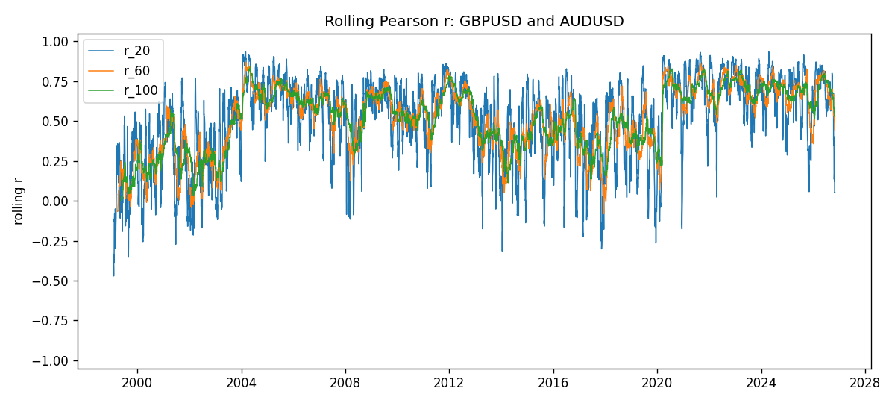
Daily closes

Daily log returns
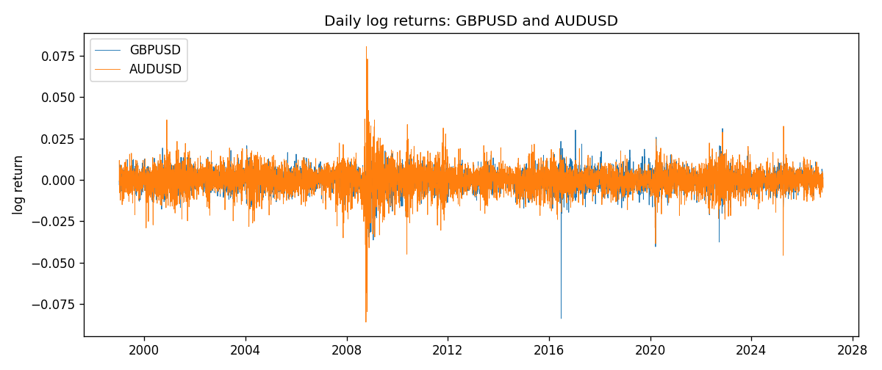

Data report
Every matched row with r_20, r_60, and r_100 is in the sibling CSV and HTML. This Word section holds column summaries and the first and last 15 rows of the rolling table.
Columns: time, GBPUSD_close, AUDUSD_close, GBPUSD_tick_volume, AUDUSD_tick_volume, GBPUSD_log_return, AUDUSD_log_return, r_20, r_60, r_100
Column summaries
column | count | mean | std | min | 25% | 50% | 75% | max
GBPUSD_close | 7228 | 1.51674 | 0.218304 | 1.06879 | 1.32568 | 1.51203 | 1.63248 | 2.1065
AUDUSD_close | 7228 | 0.751969 | 0.135327 | 0.4786 | 0.661188 | 0.731775 | 0.809315 | 1.10169
GBPUSD_tick_volume | 7228 | 94565.3 | 153331 | 62 | 9974.5 | 52775.5 | 91622.5 | 1.27337e+06
AUDUSD_tick_volume | 7228 | 77126.2 | 137934 | 109 | 5406 | 43250.5 | 71246.8 | 1.23462e+06
GBPUSD_log_return | 7228 | -2.954e-05 | 0.0056473 | -0.0838824 | -0.00313242 | 3.002e-05 | 0.00317333 | 0.0311265
AUDUSD_log_return | 7228 | 1.629e-05 | 0.00754363 | -0.0860252 | -0.00386494 | 0.00027649 | 0.00415111 | 0.0806166
r_20 | 7209 | 0.511504 | 0.25718 | -0.47111 | 0.35471 | 0.567664 | 0.713192 | 0.934441
r_60 | 7169 | 0.51721 | 0.203305 | -0.0808299 | 0.373979 | 0.56034 | 0.678695 | 0.869203
r_100 | 7129 | 0.520407 | 0.187357 | -0.00162293 | 0.376891 | 0.554486 | 0.67825 | 0.843599
First 15 matched rows
time | GBPUSD_close | AUDUSD_close | GBPUSD_log_return | AUDUSD_log_return | r_20 | r_60 | r_100
1999-01-05 | 1.6547 | 0.6215 | -0.00289663 | -0.000804182
1999-01-06 | 1.6537 | 0.6289 | -0.000604522 | 0.0118364
1999-01-07 | 1.6502 | 0.6345 | -0.00211871 | 0.00886503
1999-01-08 | 1.6405 | 0.6347 | -0.00589542 | 0.000315159
1999-01-11 | 1.6312 | 0.6393 | -0.00568513 | 0.00722138
1999-01-12 | 1.6349 | 0.6362 | 0.0022657 | -0.00486085
1999-01-13 | 1.6499 | 0.6312 | 0.00913304 | -0.00789021
1999-01-14 | 1.6531 | 0.6295 | 0.00193763 | -0.00269692
1999-01-15 | 1.6502 | 0.634 | -0.00175582 | 0.0071231
1999-01-18 | 1.6522 | 0.6346 | 0.00121124 | 0.000945925
1999-01-19 | 1.6553 | 0.6392 | 0.00187453 | 0.00722252
1999-01-20 | 1.6472 | 0.64 | -0.00490538 | 0.00125078
1999-01-21 | 1.6524 | 0.6405 | 0.0031519 | 0.000780945
1999-01-22 | 1.6565 | 0.6327 | 0.00247817 | -0.0122527
1999-01-25 | 1.6585 | 0.6302 | 0.00120664 | -0.00395915
Last 15 matched rows
time | GBPUSD_close | AUDUSD_close | GBPUSD_log_return | AUDUSD_log_return | r_20 | r_60 | r_100
2026-10-13 | 1.32534 | 0.69821 | 0.00364343 | 0.00350077 | 0.67714 | 0.668174 | 0.647318
2026-10-14 | 1.31884 | 0.69715 | -0.00491647 | -0.00151932 | 0.618073 | 0.663656 | 0.644176
2026-10-15 | 1.32757 | 0.69191 | 0.00659764 | -0.00754471 | 0.384648 | 0.542655 | 0.585544
2026-10-16 | 1.33257 | 0.69426 | 0.00375921 | 0.00339064 | 0.403167 | 0.55064 | 0.589576
2026-10-19 | 1.33024 | 0.6978 | -0.00175003 | 0.005086 | 0.350812 | 0.537414 | 0.579888
2026-10-20 | 1.3377 | 0.70022 | 0.00559234 | 0.00346204 | 0.401066 | 0.546718 | 0.584366
2026-10-21 | 1.33937 | 0.70275 | 0.00124763 | 0.00360664 | 0.204695 | 0.587063 | 0.578924
2026-10-22 | 1.33967 | 0.70186 | 0.000223961 | -0.00126726 | 0.175691 | 0.534544 | 0.578433
2026-10-23 | 1.33684 | 0.70353 | -0.00211469 | 0.00237657 | 0.135573 | 0.521811 | 0.550423
2026-10-26 | 1.33359 | 0.70128 | -0.00243407 | -0.00320328 | 0.169021 | 0.508861 | 0.553018
2026-10-27 | 1.33044 | 0.70245 | -0.00236484 | 0.00166699 | 0.122339 | 0.497983 | 0.558009
2026-10-28 | 1.33254 | 0.70533 | 0.00157718 | 0.00409155 | 0.216192 | 0.500616 | 0.560187
2026-10-29 | 1.33733 | 0.70245 | 0.00358819 | -0.00409155 | 0.0825724 | 0.464804 | 0.535693
2026-10-30 | 1.33913 | 0.70316 | 0.00134506 | 0.00101024 | 0.0505391 | 0.454561 | 0.536153
2026-11-02 | 1.3406 | 0.69971 | 0.00109713 | -0.0049185 | 0.053272 | 0.443461 | 0.528758

